**EXPERIMENT-1**

**AIM : Write SQL queries to CREATE TABLES for various databases using DDL commands (i.e.CREATE, ALTER, DROP, TRUNCATE).**

**CREATE TABLE:**

**Creates a table with specified constraints**

**SYNTAX:**

**CREATE TABLE tablename ( column1 data_ type [constraint] [, column2 data_ type [constraint] ] [,**

**PRIMARY KEY (column1 [, column2]) ] [,**

**FOREIGN KEY (column1 [, column2]) REFERENCES tablename] [,CONSTRAINT constraint]);**

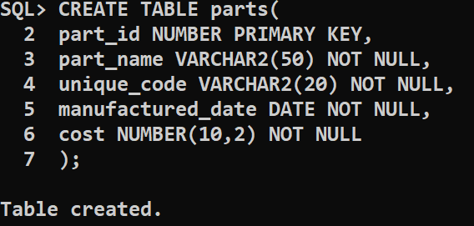

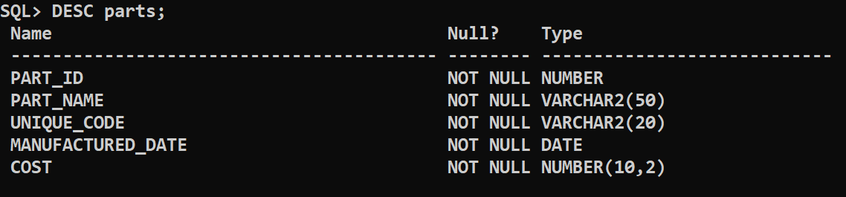

**ALTER TABLE :**

**Used to add or modify table details like column names and data types, column constraints.**

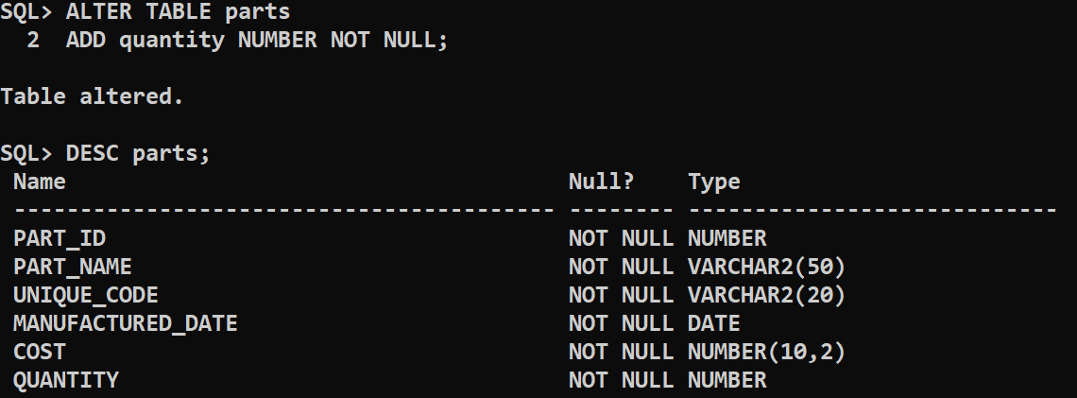

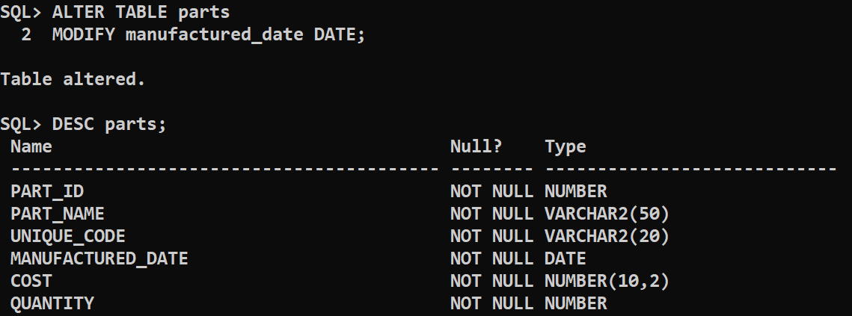

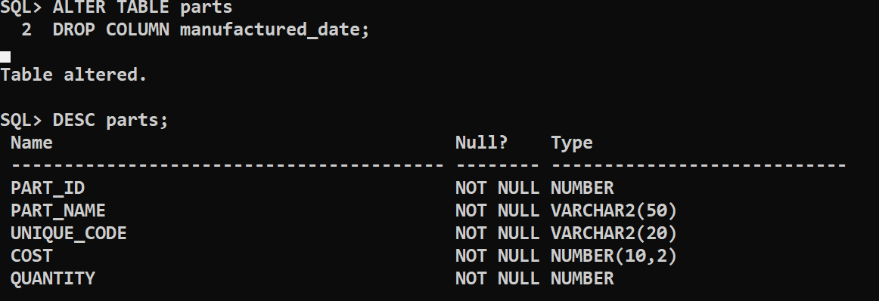

**DROP TABLE:**

Deletes the specified table.

**SYNTAX:**

DROP TABLE table_name;

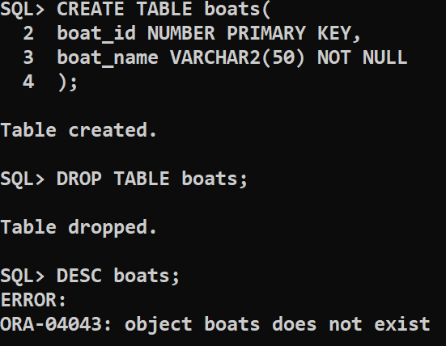

**TRUNCATE TABLE: To remove all rows in a specified table.**

**SYNTAX: TRUNCATE TABLE table_name;**

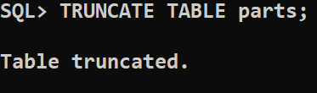

**CONCLUSION : The SQL queries to CREATE TABLES for various**

**databases using DDL commands is successfully executed.**